deliver

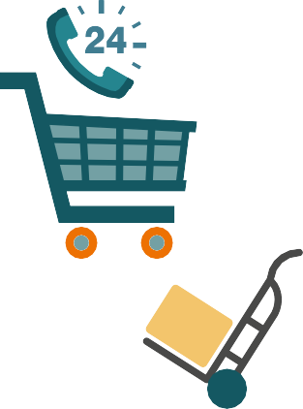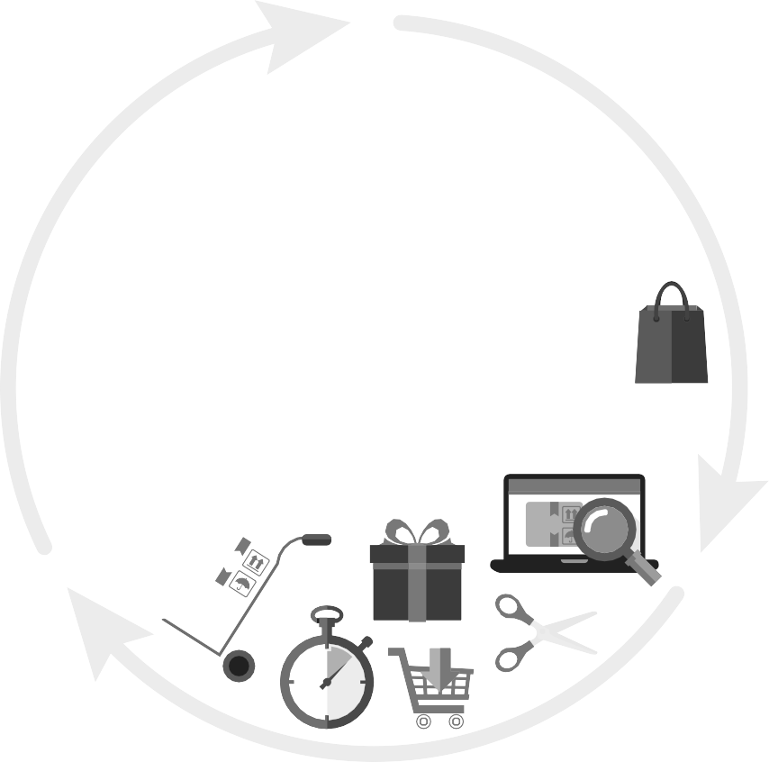

2021 Guide:

e-Commerce EU VAT reboot

How the most fundamental overhaul of the EU VAT regime in over 20 years will impact B2C sellers and marketplaces



Contents

# Introduction

* + Making compliance easier and fraud harder
  + 3 fundamental changes to e-commerce EU VAT

3 Reforms

# A single EU VAT return for e-commerce

* + Ending the distance selling threshold rules
  + Launching the single OSS EU VAT return for B2C goods
  + Exemptions for micro-businesses
  + B2C services via OSS
  + Brexit implications
  + Closing the delivery VAT avoidance loophole

# Closing the low value consignment stock loophole

* + Switching import VAT to point-of-sale – Green Channel clearance
  + IOSS import VAT simplified reporting
  + Brexit implications
  + Simplified customs declaration
  + ‘Special Arrangements’ Postal services’ role

# Marketplaces become the deemed supplier

* + Defining a marketplace
  + Is the marketplace facilitating the sale?
  + Which transactions are in scope?
  + Two-stage VAT transaction
  + Calculating the €150 intrinsic consignment value
  + Marketplace recordkeeping obligations
  + Brexit implications

Page 3

Page 5

Page 10

Page 12

On 1 July 2021, the member states of the European Union (EU) will introduce sweeping reforms to the VAT obligations of B2C e-commerce sellers and marketplaces.

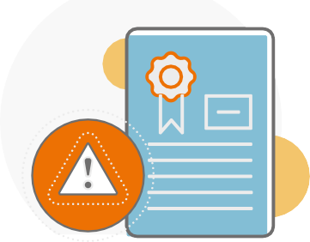

Making compliance easier and fraud harder

The key reform will mean some sellers will be able to report all their pan-EU distance sales on a single VAT return in their home country instead of having multiple VAT registrations across the EU. The aim is to boost cross-border online trade and promote trade across the EU’s digital single market by reducing compliance obligations.

The changes also seek to tackle the stubborn €7 billion e-commerce VAT fraud gap, with member states looking to close import loopholes and co-opt online marketplaces into collecting VAT in place of sellers – the ‘deemed supplier’ rules.

This guide provides an overview of the major reforms, and how it will affect sellers and marketplaces’ obligations. This is based on three major reforms planned for 2021.

A single EU VAT return for e-commerce

When the reforms come into effect, the existing ‘Distance Selling Thresholds’ rules will be withdrawn.

This will be accompanied by the roll out of a single EU VAT return, One Stop Shop (‘OSS’). Sellers shipping goods from their home country to customers across the EU may opt to use OSS to report all their pan-EU sales.

This is instead of the current requirement of being VAT registered in each country. OSS is an extension of the 2015 Mini One-Stop-Shop (‘MOSS’), which successfully trialed a single EU return for B2C sales of digital services (streaming media, e-books, apps etc.).

### Implications

No action is required today.

From July 2021, some e-commerce sellers will be able to close their foreign VAT registrations. They can instead complete a OSS return for their home country’s tax authority.

Non-EU sellers may use OSS when their product is first imported into the EU and subsequently distributed throughout the EU. OSS will list sales by EU country, VAT % used, and VAT due. This VAT must be paid to the home country’s (or Member State of identification’s) tax office.

Note: Sellers holding stock in warehouses in other EU states will still have to remain foreign VAT registered following the 2021 reforms. This includes sellers using the Fulfilment by Amazon (FBA) program.

### Closing the import VAT exemption loophole

From July 2021, the €22 VAT exemption on small parcels being imported into the EU for delivery to consumers will be withdrawn.

This exemption has been heavily abused by many sellers mistakenly or deliberately

under-declaring the import values of goods to avoid VAT. Instead, VAT must be charged at the point-of-sale for transactions up to the value

€150.

This VAT may then be declared and paid via a new submission, the Import One Stop

Shop’ (IOSS). This will create a more efficient fast-track, or ‘Green Channel’, for customs clearance.

### Implications

After July 2021, EU sellers will no longer be disadvantaged on price, as all sellers will have to charge VAT on all imported goods.

Non-EU sellers can opt to register for IOSS in just one EU state to declare the VAT on any affected imports on shipments below €150.

However, non-EU sellers will require at least one regular VAT registration in one Union member state. There are instances where a facilitating marketplace (see marketplace deemed supplier rules), or delivery service may step in to report and pay the VAT.

If any seller chooses not to use the IOSS, the customer will have to pay the delivery or customs agent to access their goods.

### Marketplaces become the deemed seller and VAT collector

The 2021 reforms will oblige marketplaces which facilitate cross-border sales to consumers via third parties to become the ‘deemed seller’ in certain cases. This is also termed the full liability regime. This marketplace VAT liability does extend to product liability.

The EU has defined ‘facilitating’ as “electronic platforms assisting sellers and consumers to come together and strike a contract for the supply of goods on a cross-border basis”.

The new deemed supplier regime will apply in two use cases when the marketplace is facilitating a B2C sale: imports with a cross- border transaction not exceeding €150 by EU and non-EU sellers; and sales within the EU by non-EU sellers only for transactions of any value.

There is scope for the marketplace to opt out of this scheme (the ‘Special Arrangement’), and the VAT obligations to be transferred to the delivery company of the seller.

### Implications

After July 2021, marketplaces will become responsible for charging and collecting VAT on deemed seller transactions.

However, the marketplace does not take on product liability or regulatory obligations. For imports not exceeding €150, instead of import VAT, the marketplace will charge the customer output VAT at the point-of-sale and declare it instead of the seller. Both EU and non-EU sellers will benefit from reduced VAT obligations and may be able to deregister in some EU states.



### At the heart of the 2021 e-commerce EU VAT reboot is the introduction of the One-Stop-Shop (‘OSS’) single EU VAT return.



A single EU VAT return for e-commerce

From July 2021, B2C sellers dispatching their goods from a single country will no longer be required to register for foreign VAT and complete multiple VAT filings in countries where they are selling. Instead, they may opt to simply complete and file a single OSS filing that will list all their pan-EU sales with their regular domestic VAT return that will list all their pan-EU sales. The seller then remits the VAT due to their home VAT authority, which then forwards the taxes to the appropriate countries. Non-

EU sellers may also apply to use the OSS regime, and just need to nominate any single EU state – ‘member state of identification’ to register and file in.

This builds on the successful launch of the single VAT return for B2C digital services in 2015, referred to as the MOSS return.

### Ending the distance selling threshold rules

EU distance selling thresholds until July 2021

€100,000 per annum: Germany, the Netherlands, Luxembourg, UK (£70,000) during its Brexit transition period until 31 December 2020.

For all other 24 members of the EU it is €35,000 per annum or local currency equivalent.

The current EU VAT regime ‘place of supply’ rules require sellers to charge the VAT of their customer’s country of residence – known as the destination principle. For EU cross-border sales this currently means sellers have to VAT register in each country where they are selling goods.

Currently, to reduce the burden on small sellers, the EU operates a special VAT registration simplification for e-commerce, known as distance selling thresholds. This is generally only available for sales from a seller’s domestic stocks.

From 1 July 2021, this registration threshold simplification will be withdrawn. Cross-border sellers will have to charge the VAT rate of the customer’s country of residence from their first sale and remit it to the foreign tax authorities.

Launching the single OSS EU VAT return

At the same time as withdrawing the distance selling thresholds, the EU is extending the single VAT return, OSS, to e-commerce cross-border distance selling of goods and services (see below). This will replace the obligation to VAT register in every country where sellers are making sales to EU consumers from stocks in a single EU location – typically their home state.

*NOTE: Sellers holding stock in other EU countries will not benefit from the OSS single return simplification. They must remain VAT registered in each country where they are holding stock to record any intra-community goods movements. This includes selling using the Amazon FBA program.*

The existing obligation to register in all countries is often called out as the principal barrier to cross-border trade in the EU. A single VAT return, listing all pan-EU sales, has already been in place (known as the Mini One-Stop-Shop, MOSS) since 2015 for B2C cross-border sales of digital, telecoms and broadcast services.

Sellers with existing foreign VAT registrations, and selling from stock in their country of residence, may opt to close these non-resident registrations from 1 July 2021 and use the OSS report instead.

Sellers will continue to declare any sales to customers in their own country of residence through their existing domestic VAT return. OSS

may be used to report cross-border B2C traditional services; and certain domestic sale facilitated by marketplaces.

The OSS filing is in addition to the regular domestic VAT return. Firstly, sellers will charge VAT at the rate of their customer’s country of residence. They can use the delivery address of their customer to identify the country of residence. Then determine the correct VAT rate, as well as applying reduced or nil VAT rates, according to the varying rates and goods classifications of each member state of their customers.

The OSS filing will be a quarterly return. It is intended as a simple listing to declare VAT due by the seller to each EU country apart from the domestic state. The OSS return will be standardized across all the EU member states, and will be structured as follows:

### Example OSS return from 2021

Non-EU sellers

Sellers who are non-resident in the EU may also use the OSS simplified filing.

They can then file regular OSS filings like any EU e-commerce seller. There is no need to file a regular domestic VAT return unless the non-EU seller is holding stocks in the relevant country.

VAT incurred on imports may be declared in the OSS, too.

|  |  |  |  |  |
| --- | --- | --- | --- | --- |
| Member state | VAT rate type | Vat rate in member state | Total value of supplies exc VAT | VAT due |
| France | Standard | 20% | €238,000 | €47,600 |
| Reduced | 5% | €15,000 | €750 |
| Germany | Standard | 19% | €340,000 | €64,600 |
| Reduced | 7% | €0 | €0 |
| Spain | Standard | 21% | €123,000 | €25,830 |
| Reduced | 10% | €4,500 | €450 |
| Poland | Standard | 23% | €8,000 | €1,840 |
| Reduced | 8% | €0 | €0 |
| Other states... |  |  |  |  |
| Total |  |  |  | €141,070 |

The amounts should be shown in the seller’s domestic country’s currency. In the case of a foreign currency translation, sellers should be following their domestic country’s guidance on rates to use at the date of the transaction.

## Filing OSS

The OSS filing should be submitted on the same date as the regular VAT return. This is usually done through the tax authority’s regular online portal.

Taxpayers on monthly VAT returns should consult their local tax authority’s website to check the due date. The VAT due should be remitted by the same deadline.

The domestic tax authorities will then be responsible for dividing up and paying the VAT received from the seller to each country as appropriate.

### What will this mean for a typical seller?

To show how this will affect a typical EU seller, let us look at the VAT filing obligations for an example seller today, and after the 2021 reforms.

Eurotrade GmbH, established in Austria, sells online to consumers across the EU. It holds most of its stock in Austria, from where it ships. However, it holds some stock in France for speedy delivery to its French consumers.

Eurotrade GmbH annual sales, and VAT obligations are as follows:

|  |  |  |  |  |  |
| --- | --- | --- | --- | --- | --- |
| Country of customer | Annual sales | VAT today | | VAT July 2021 | |
| Germany | €780,0002 | Austrian domestic VAT return | Austrian 20% | Austrian domestic VAT return | Austrian 20% |
| Spain | €54,0001 | Spanish VAT return | Spanish 21% | OSS | Spanish 21% |
| Italy | €42,0001 | Italy VAT return | Italian 22% | OSS | Italian 22% |
| Hungary | €23,0002 | Austrian domestic VAT return | Austrian 20% | OSS | Hungarian 27% |
| Luxembourg | €75,0002 | Austrian domestic VAT return | Austrian 20% | OSS | Luxembourg 17% |
| France | €75,0003 | French VAT return | French 20% | French VAT return | French 20% |

1. – Today, above the Distance Selling Threshold so must foreign VAT register; post-2021 may close this registration
2. – Today, below the Distance Selling Threshold so report sales under Austrian rules; post-2021 switches to foreign VAT, reported via OSS
3. – Today, holding stock in foreign country so must VAT register there; post-2021 must remain foreign VAT registered in France

### Exemption for micro-businesses

The EU will grant micro-businesses an exemption from the OSS rules. This reflects the experience of the roll-out of the 2015 MOSS return which imposed overly complex customer tracking and VAT calculations on the smallest of sellers.

Any businesses selling less than €10,000 per annum cross-border on B2C goods and services will be exempt from the obligation to complete an OSS return.

Instead, they will be able to charge their domestic VAT rate and report the sales below this threshold in their regular domestic VAT return.

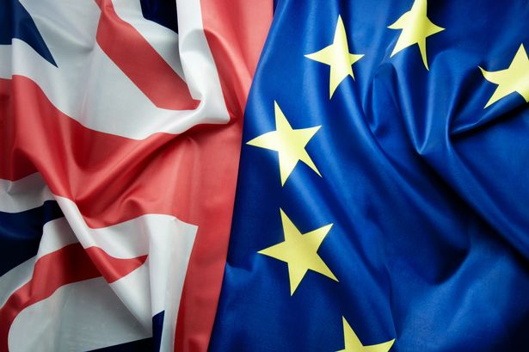



Brexit – the effect for UK and EU sellers

The UK left the EU on 31 January 2020. Under the Brexit Withdrawal Agreement, it will leave the EU VAT regime on 31 December 2020. This means UK sellers will be non-EU sellers at the time of the introduction of July 2021 e-commerce reforms. UK resident sellers may have to register in one of the EU states to file a ‘non-Union’ OSS return.

UK sellers will still be able to close any EU VAT registrations if they are distance selling to the EU.

EU sellers distance selling to UK customers after 30 June 2021 will have to consider opening a UK VAT non-resident registration, if not already in place, since the OSS will not cover post-Brexit UK.

### B2C services via OSS

In addition to reporting B2C goods on the new OSS VAT return, businesses may also include certain services. These are:

* Electronic, telecoms and broadcast services currently reported via the single MOSS return. These include streaming or download media; apps; e-books; subscriptions to journals or membership site; web services; and
* ‘As-performed-services’ traditional services sold online. These include training and education; ticket sales for events; and transport.

Non-EU sellers may also use the OSS return for services. However, they must use a separate non-Union OSS registration

and filing procedure.

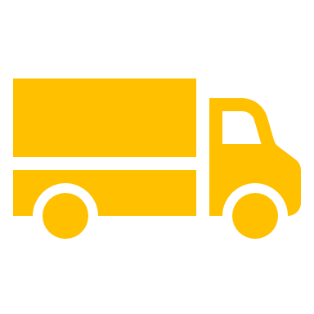



### Closing the delivery VAT avoidance loophole

The EU member states have also agreed to close a delivery loophole being exploited by some e-commerce sellers to avoid charging and reporting foreign VAT.

A limited number of sellers are not directly providing delivery to the foreign consumer; instead organizing a third-party fulfilment firm for the customer to sign a separate delivery contract. This potentially means the seller could just charge their national VAT rate instead of that of the customer’s country of residence.

To ensure that the tax authorities of the customer will be getting their fair share of VAT, the EU is closing this avoidance loophole in 2021.

Where the seller ‘indirectly intervenes’ to provide transport on a cross-border sale, they will have to charge the VAT of their foreign EU customers, and report it through their OSS filing or non-resident VAT return.

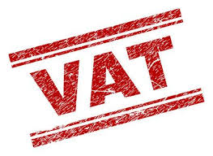



Recovering foreign VAT

OSS does not allow sellers to recover local VAT incurred on hotel or taxi travel, for example.

Sellers will have to complete an 8th Directive VAT recovery claim for these reclaims. Similarly, non-EU sellers will still be required to complete a 13th Directive claim.

OSS is voluntary

Lastly, it will not be obligatory to use the OSS return. Sellers may still keep their foreign VAT registrations open and report local sales and VAT through them.

Today, EU and non-EU sellers selling goods online to EU consumers can ship the goods into the EU, directly to the consumer, import VAT-free if the goods are valued at €22 or below.



Closing the low-value consignment stock loophole

This exemption, termed the ‘low value consignment stock relief’, was intended to relieve customs from the burden of checking large volumes of packages for small amounts of potential tax revenues.

However, it is leaving EU-based sellers at a major price disadvantage since they must charge VAT when the goods were dispatched from within the EU. The exemption has also encouraged large-scale fraud by sellers deliberately under-declaring the values of goods to escape the import VAT bill.

### Switching import VAT to point-of-sale – Green Channel clearance

The EU has therefore agreed to scrap the import VAT exempt threshold. Instead, it will require EU and non-EU sellers to charge VAT at the point of sale for consignments of €150

or below. This will create a more efficient ‘Green Channel’, with quick and easy customs clearance. Note – alternatively, delivery agent may act as the import VAT collector (‘Special Arrangements’).

Sellers will charge VAT at the rate of their customer’s EU country of residence at the point-of-sale on the website. Sellers can use the delivery address of the customer to determine the country VAT rate. No VAT is due at the point of import in this case.

### IOSS import VAT simplified reporting

To report the VAT charged at the point of sale, a new declaration, ‘Import One-Stop-Shop’ (IOSS), is being introduced. This will report distance selling across EU borders of imported consignments not exceeding €150. Sellers, or deemed supplier marketplaces, may register for IOSS in just one EU state. They will be issued a unique IOSS identification number which should be listed on all custom declarations sent to the EU. This will indicate to customs that VAT is being properly declared and help ensure speedy customs clearance.

Like the OSS, IOSS will be a regular filing submitted to a tax authority in one nominated EU member state. It will declare output VAT due in all EU countries. The format and due dates will be similar to the VAT OSS. Sellers will have to make a single cash payment of the VAT due to the country where they are IOSS registered.

### Non-EU sellers and the IOSS

Non-EU sellers selling goods located outside of the EU to EU customers may also use the IOSS. It will be practically useful where the seller’s customers are located in other EU states and the seller wants to take care of the import VAT on behalf of their consumer. It also relieves the seller of having to undertake a full VAT registration in each country it is importing into.

Non-EU sellers will have to appoint an Intermediary, a type of fiscal representative, in their chosen ‘member state of identification’

### What will this mean for a typical non-EU seller?

To understand the effects on a typical non-EU seller, let us consider the VAT obligations today and post-2021 reforms for an example non-EU seller, ShanghaiTrade LLC from China.

|  |  |
| --- | --- |
| Today | ShanghaiTrade LLC can sell and ship goods under €22 to EU consumers VAT free. Over that limit, then either the customer or ShanghaiTrade LLC has to pay import VAT at the rate of the country of import. To provide a good seller experience, ShanghaiTrade LLC pays the import VAT on behalf of its customers. |
| July 2021 | ShanghaiTrade LLC will charge VAT at the point of sale and declare it in an IOSS return if below €150. They are then exempted from paying import VAT at customs. ShanghaiTrade LLC may also declare sales to customers around the EU via its OSS return, as discussed in the above section.  For goods above the new €150 IOSS threshold, the import VAT must still be paid to customs. This could still trigger a regular VAT registration in the country of importation for ShanghaiTrade LLC if they wish to sell the goods locally or to consumers in the rest of the EU. |

### IOSS is optional - Postal service or marketplaces may declare the VAT instead

Brexit – the effect on IOSS

The UK is planning to withdraw its EU

£15 low-value consignment stock relief threshold as soon as it leaves the EU VAT regime on 31 December 2020 – the ending of the Brexit transition period. When the UK does leave the EU VAT regime, it is introducing a new £135 VAT parcel system, similar to the EU’s €150 IOSS scheme.

Non-UK sellers will require a regular UK VAT registration to report the output VAT charged at the point of sale to

UK customers on import sales not exceeding £135.

For sales to EU consumers from January 2021, British resident sellers will be considered as non-EU residents. From July 2021, they will be able to use the EU IOSS as non-Union sellers. This will require them to register in any one EU

state for the filing and VAT payments for imports not exceeding €135.

The import OSS is not compulsory for consignments not exceeding €150. Alternatively, the seller may elect to have the import VAT collected from the final customer by the customs declarant. This is generally the postal operator, courier firm or customs agent.

They can settle the VAT collected with the tax authorities via a monthly payment. This is known as the ‘Special Arrangement’.

In certain circumstances, marketplaces facilitating the sale will be responsible for the import VAT being charged at the point-of-sale for the EU or non-EU sellers. This is detailed in the next section.

### Simplified customs declaration

To help importers and customs authorities cope with the ballooning volume of low-value consignments, the standard customs declaration for goods not exceeding €150 is to be condensed. From July 2021, sellers will be able to provide a simplified declaration at the point of import into the EU. This is a ‘super- reduced dataset’ for the party declaring the import.

The existing duties exemption for most consignments not exceeding €150 will remain in place.

e-Commerce VAT evasion is estimated to cost EU member states €5 billion per annum, a figure expected to grow to €7 billion by 2021.



Marketplaces become the deemed supplier

Since online marketplace platforms now play such a controlling role in facilitating the colossal growth in online selling, EU member states have agreed to co-opt them in the fight against e-commerce VAT fraud.

From July 2021, marketplaces may become the deemed supplier when they facilitate certain cross- border B2C transactions of their third-party sellers. They will therefore be liable to collect, report and remit the VAT due from the consumer.

Whilst the marketplace takes on the VAT rights and obligations of the sale, they do not take on

other obligations, such as product liabilities. This new rule comes into force as part of the e-commerce package of reforms to help simplify VAT compliance and tackle online VAT fraud.

To understand where the new rules will apply, the following facts should be examined: defining a marketplace; is there facilitation; and which transactions are in scope. Once a deemed supply has been identified, a new two-stage VAT transaction process must be applied.

### Defining a marketplace

The EU Council implementing regulation for the July 2021 e-commerce package refers to ‘electronic interfaces’ (‘EI’), which includes online marketplaces, platform, portal or similar means. The role of the marketplace is to introduce customers and sellers offering goods for sale, and who then enter into a contract which results in a taxable supply.

Is the marketplace facilitating the sale?

A marketplace is considered to facilitate a sale when it participates in any of the following:

* Controls the terms and conditions of the sale;
* Authorizes the charge to the customer in respect of the payment for the supply; and/or
* Orders or delivers the goods.

However, the marketplace is not considered to facilitate the sale if it only provides one of the following services in relation to the sale:

* Payment processing;
* Listing or advertising the goods
* Redirecting customers to other marketplaces where the goods are offered without any further involvement in the sale.

### Which transactions are in scope?



Two types of cross-border transactions are in scope for the July 2021 deemed supplier rule changes when facilitated by a marketplace:

* 1. Import sales by EU or non-EU sellers to consumers of consignments not exceeding €150; and
  2. Goods consignments already in the EU sold by a non-EU seller to an EU consumer of any value. This may be on a distance sale (cross-border) or domestic sale basis.

### Two-stage VAT transaction for deemed supplier marketplace sales

To effect the new rules, once a seller and customer have agreed a sale, the existing single transaction procedure between the seller and customer will be split into two:

1. The seller will sell the goods to the marketplace on a B2B VAT exempt with credit basis. This means the seller remains free to deduct any input VAT suffered on the purchase of the goods. The transport of the goods will be attached to this transaction, so entitling it to zero-rating.
2. The marketplace will sell the goods to the consumer, charging the VAT rate of the consumer’s country of residence. The VAT is due at the earliest of the marketplace receiving the order, commitment or order to pay from the consumer.

To understand the marketplace facilitation use cases, let us take two examples.

Example 1: Import followed by distance selling below €150

DeutschShopper GmbH is a German-resident seller. It makes sales to French and Italian consumers via a facilitating marketplace. The goods are valued below €150, and are sourced from China and imported into France initially.

Today:

DeutschShopper is VAT registered in France to recover the French import VAT and charge 20% French VAT to the consumer. It must also be VAT registered in Italy (assume it is over the distance selling threshold of €35,000) to

report the distance sales from France to Italian consumers, and charge 22% Italian VAT.

From July 2021:

The facilitating marketplace will become the deemed supplier, and will take responsibility for the import into France in its French VAT return or IOSS declaration. See the new 2021 OSS single EU VAT return. It will charge the French and Italian consumers 20% and 22%, VAT, at the point of sale. This effectively replaces the import VAT. It follows the new rules under the withdrawal of the low-value consignment stock relief, also to be introduced in July 2021.

DeutschShopper can close its French and Italian VAT registrations if not using it for other purposes. For example, holding local stocks

in Italy, selling via its own website or selling imported goods over €150.

### Example 2: Non-EU selling goods across EU borders for any value

US Seller Inc, is a US-resident seller. It buys goods in France for resale to French and Austrian consumers via a facilitating marketplace.

#### Today:

US Seller is French VAT registered to charge 20% French VAT on domestic sales, and to recover the French import and input VAT it is charged when it imports and buys local stocks. It is also Austrian VAT registered (assume it is over the Austrian distance selling threshold of €35,000) to charge 20% Austrian VAT to consumers on goods sent from France.

#### From July 2021:

The facilitating marketplace will become the deemed supplier for the French and Austrian sales to local consumers. The marketplace will report the sales through either its own local VAT registration in France or Germany. Or, if the marketplace does not have a local registration, it can instead use its single EU IOSS and OSS for sales in France and Austria.

US Seller may deregister from France and Austria – unless it is selling on its own website or holding stocks locally. It must keep open

its French VAT registration to report the sale to the marketplace. Lastly, it can recover the Austrian VAT it paid when initially buying its stock via a 13th Directive VAT recovery claim.

### Calculating the €150 intrinsic consignment value

A major challenge for the new import scheme is the calculating the €150 consignment threshold for the IOSS reporting. It relates to customs declared value of a single package or consignment being cleared through customs to a single customer. So if it is made-up of multiple goods, they must be summed together to determine if the consignment qualifies for the IOSS scheme.

On marketplaces, often a shopper will buy goods from multiple sellers and then checkout. The organizer of the dispatch or marketplace may package these goods in a single consignment for dispatch. If the combined value of the goods exceeds €150, then the VAT treatment, collections and reporting cannot fall under IOSS. Marketplaces may therefore have to adjust the VAT determination after the checkout which will present some issues.

To alleviate this, and to avoid double taxation if goods with output VAT then attract customs import VAT when clearing into the EU country, it will be possible for the customer to seek a VAT refund. This will be off the facilitating marketplace or seller – whichever party was responsible for charging output VAT.

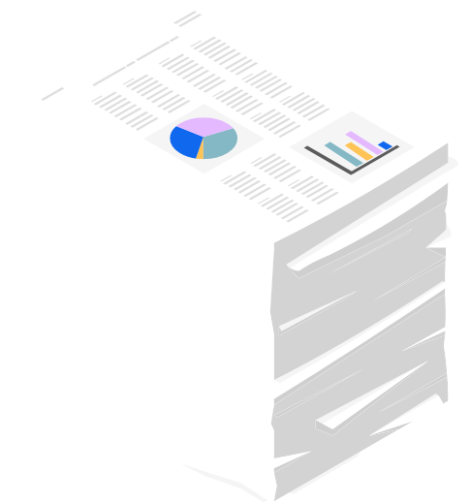

Marketplace recordkeeping obligations

In addition to taking on potential deemed supplier VAT responsibilities, marketplaces will also have new record keeping responsibilities. They will be required to keep sellers’ transactions in sufficient detail to enable tax authorities in the country of the customer to check that VAT has been correctly accounted for. They must be held electronically for at least 10 years after the year of the transaction.

Even where the marketplace has not ‘facilitated’ the sale, it is still obliged to maintain basic transactional data for each seller, and their VAT numbers.



Marketplace liable for misdeclared VAT?

A marketplace will not be held liable for underpaid VAT on deemed supplier transactions where the seller provided it with erroneous information that was required for the VAT calculation. But the marketplace will have to demonstrate that it did not and could no reasonably have known that the information was incorrect.

Brexit implications?

The UK left the EU on 31 January 2020, and will leave the EU VAT regime on 31 December 2020. The July 2021 deemed supplier marketplace reforms will therefore not apply to transactions in the UK.

EU and non-EU sellers will be responsible for declaring UK sales VAT when they import and sell to UK consumers.

The UK has recently started an industry consultation on introducing its own version of the marketplace deemed supplier regime. This

is likely to mirror the EU scheme in most elements. It will launch sometime in 2021.

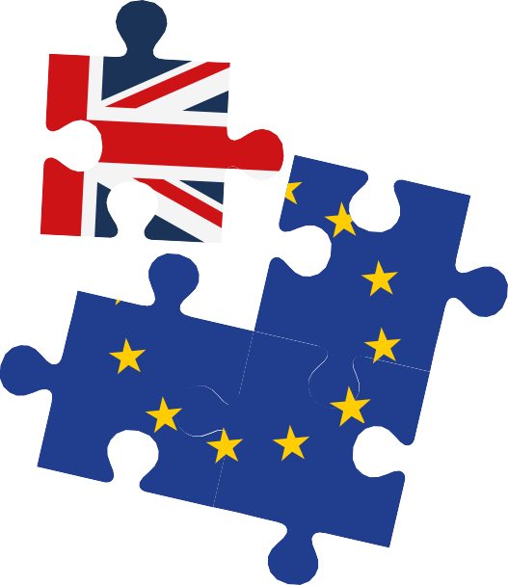

ABOUT FREIGHTWAYS

### Supply Chain Solutions

### It is Freightways’ mission to offer complete logistic services of high quality to our customers who we unburden by commanding part, or all, of their supply chain in a transparent, flexible and reliable manner.

### Our service package includes warehousing, distribution, fiscal representation, e-fulfilment, value added services and international freight forwarding.

### Thanks to a central location in The Netherlands, in between Port of Rotterdam and Schiphol Airport in Amsterdam, we are perfectly situated to handle distribution throughout Europe.

### More information at:

### [www.freightways.eu](http://www.freightways.eu)

### [info@freightways.nl](mailto:info@freightways.nl)

### or call us on: +31 71 40 90 701